INFORMAL LETTER - Format of Informal letter and Examples
“Letter writing is the only device for combining solitude with good company”
- Lord Byron

What is an Informal letter?
An informal letter, also referred to as a friendly letter, is a personal letter written to friends or relatives. It is written in personal fashion. You can write it to anyone with whom you have a non-professional relationship, although this doesn't exclude business partners or workers whom you're friendly with either.
There are fewer formatting rules for informal letters than there are for business or formal letters. The letter can be used for some reasons like conveying message, news, giving advice, congratulate recipient, request information, asking questions, etc. It is a personal letter, written to whom you are familiar with, like friends, siblings, parents or any other closed one. While writing an informal letter, one can afford to be friendly, and make use of personal or emotional tone.

Difference between Formal letter and Informal letter
The formal letter is written for business or professional purposes with a specific objective in mind. It uses simple language, which is easy to read and interpret. On the contrary, informal letters are written to friends and relatives for personal communication and require a casual or an emotional tone.
The size of a formal letter should be concise; that does not include irrelevant matter. In contrast, the informal letter can be lengthier.
Formal letters are used for writing letters to business contacts, i.e. partners, suppliers, customers, clients, etc. , college or institute, employer, professionals, etc. As against this, we write informal letters to friends, relatives, acquaintance, etc.

Format of Informal letter
There is no set format when writing an informal letter. But there is a general pattern, some conventions that people usually follow. We will be looking at this pattern and certain tips on how to write effective and attractive informal letters. These can act as guidelines when you are drafting a letter; they are not hard and fast rules. Let us begin.
Address
The first thing to write is your address, i.e. the address of the writer (basically, the sender’s address). We usually write the address on the left-hand side of the page at the very top. The address should be accurate and complete. Even when writing to close friends or relatives the address must be written, so they can reply back to the letter with ease. If the recipient of the letter is in another country, do not forget to write your country as well in the address.
Date
Next just below the address we write the date. This allows the reader to have a reference as to when the informal letter was written. He can then relate better to the contents of the letter. The date, preferably, shold be in expanded form.
Greeting
Now since you know the person you are writing to, the greeting can be informal as well. If it is a friend or someone close to your age you can greet them by their first name, like “Dear Alex”. If you are writing to your relative like your mother/father/aunt/uncle etc, you may greet them as such, for example, “Dear Mom”. And if you are writing to an elder person, someone you respect greatly you can address them as Mr or Mrs. Like say for example you were writing a congratulatory letter to your teacher, it can be addressed as “Dear Mrs. Alex”.
Introductory Paragraph
And now we begin writing the actual letter. The introductory paragraph sets the tone for the whole letter. You might begin by asking the recipient about their well being. Or you may say that you hope the letter finds them in good health and great spirits. The opening of informal letters should be casual and comforting. It must not be formal and direct as in business letters.
Body of the Letter
The letter overall should maintain a friendly tone. But you have to adjust the language and the wordings according to who you are writing to. With a friend, you can afford to be very casual and flippant even. But if you are writing to an elder relative, you must be extremely respectful and considerate.
One way to determine the tonality of your letter is to remember how you talk to the person in a conversation. And then apply the same syntax and sentiments to the letter.
Conclusion
In the conclusive paragraph sum up the reason for writing the letter, i.e. summarize the letter. Say a meaningful and affectionate goodbye to the reader. And do not forget to invite the reader to write back or reply to your letter. It shows an intention to keep the conversation going.
Signature
There is no one way to sign off informal letters. Since they do not follow a strict format, you may sign off as you please. Some commonly used phrases are
- Lots of Love
- Best,
- Best Wishes,
- Kind Regards,
- Kindly,
Marking Scheme of question on Informal letter
Format  1. sender's address,  2. date,  3. receiver's address,  4. subject / heading,  5. salutation,  6. Complimentary close. | 01 mark
Content | 03 marks
Expression  - grammatical accuracy, appropriate words and spelling  - coherence and relevance of ideas and style | O2 marks:  1  1
Total | 06 marks
Tips for writing Informal Letter
- Make sure you double check for grammatical accuracy and spellings. They carry marks.
- Leave adequate number of lines between paragraphs to make it look neat.
- Underlining the main points is very important. But it is advised to do it after finishing your exam. Use a pencil and scale for underlining.
- Presentation is very important.
- Read a lot of letters to get an idea.

Topics for Informal Letter
Below is a list of a few important topics-
- Inviting a friend
- Advising a friend
- Apologizing to a friend
- Thanking a friend for spending holiday together
- Reminding a friend
- Congratulating a friend
- Requesting for help
- Admitting a mistake

Examples of Informal letter

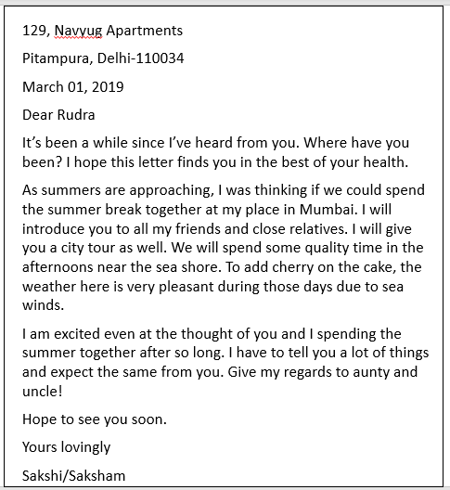

Question 1: Write a letter to your friend congratulating him/her on his/her success in class 12 board exam.
Answer:
B-32, sector-11
Rohini
New Delhi-110034
July 10, 2018
Dear Muskan
My happiness knew no bounds when I got to know that you have topped your school and achieved your dream. I felt so pleased that I wish I were there to congratulate you personally.
The result has proved that hard work, determination and perseverance bring good results. You were so laborious and passionate about it. I know you were very nervous too, but I was always very confident that you would come out with flying colours. I apologise that I couldn’t even attend the celebration party despite my wishes.
Hope to see you soon. Please be encouraged and continue your hard work. Your future is very bright. My parents and elder sister have sent lots of love and heartiest congratulations.
With lots of love and best wishes.
Yours lovingly
Shefali

